H.T No
Regulations:
A18

Sreenidhi Institute of Science and Technology
(An Autonomous Institution)
Code No: 7EC01 Date: 30-Dec-2022 (FN)

B.Tech II-Year II- Semester (A18) Special Supplementary Examination - December-2022
DATA STRUCTURES (ME and ECE)

Time: 3 Hours Max.Marks:70

Note: a) No additional answer sheets will be provided.
b) All sub-parts of a question must be answered at one place only, otherwise it will not be valued.
c) Missing data can be assumed suitably.

ANSWER ANY 5 OUT OF 8 QUESTIONS. EACH QUESTION CARRIES 14 MARKS.

Bloom's Cognitive Levels of Learning (BCLL)
Remember | L1 | Apply | L3 | Evaluate | L5
Understand | L2 | Analyze | L4 | Create | L6

 |  |  | BCLL | CO(s) | Marks
1. | a) | What is a Queue? Briefly explain the basic operations of Queue. | L2 | CO1 | [7M]
 | b) | Evaluate the Postfix Expression AB+CD/E*F%- using Stack. The values of the variables are a=2, b=3, c=5, d=2, e=4 and f=6. | L5 | CO1 | [7M]
2. | a) | Write a function to delete an element in the middle of a singly linked list. | L6 | CO2 | [7M]
 | b) | Given a circular linked list specify the approach used for insertion of an element at the ending. | L4 | CO2 | [7M]
3. | a) | Write about representation of Binary Tree using Linked List. Represent the following Binary Tree using linked list representation.  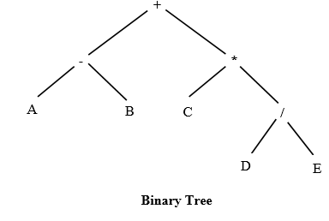 | L2 | CO3 | [7M]
 | b) | Create a Binary Tree for the following data 13, 80, 17, 56, 24, 52, 07, 32. | L2 | CO3 | [7M]
4. | a) | What is a Binary Search Tree (BST)? Create a BST for the following sequence of numbers.  55, 36, 70, 23, 89, 100, 58, 39, 41, 60, 65, 25 | L5 | CO4 | [7M]
 | b) | Write an algorithm for Quick sort and explain with an example. | L2 | CO4 | [7M]
5. | a) | Compare and contrast Structured programming with Object Oriented programming. | L4 | CO5 | [7M]
 | b) | Can we initialize a class/structure member variable as soon as the same is defined? Explain with an example. | L2 | CO5 | [7M]
6. | a) | Define inheritance. Write in brief about the types of inheritance. | L3 | CO6 | [7M]
 | b) | Define friend function. List the properties of friend function. | L2 | CO6 | [7M]
7. | a) | Write a C Program to convert infix expression to postfix expression. | L2 | CO1 | [5M]
 | b) | What are the advantages of Linked lists over arrays? | L2 | CO2 | [5M]
 | c) | Differentiate between DFS and BFS. | L4 | CO3 | [4M]
8. | a) | Consider an array of 100 sorted numbers. Almost how many searches are needed to search an element using Binary Search in the worst case. Justify your answer. | L4 | CO4 | [5M]
 | b) | List advantages and applications of OOPs concepts. | L1 | CO5 | [5M]
 | c) | What is dynamic binding? | L1 | CO6 | [4M]

-- 00 -- 00 –

